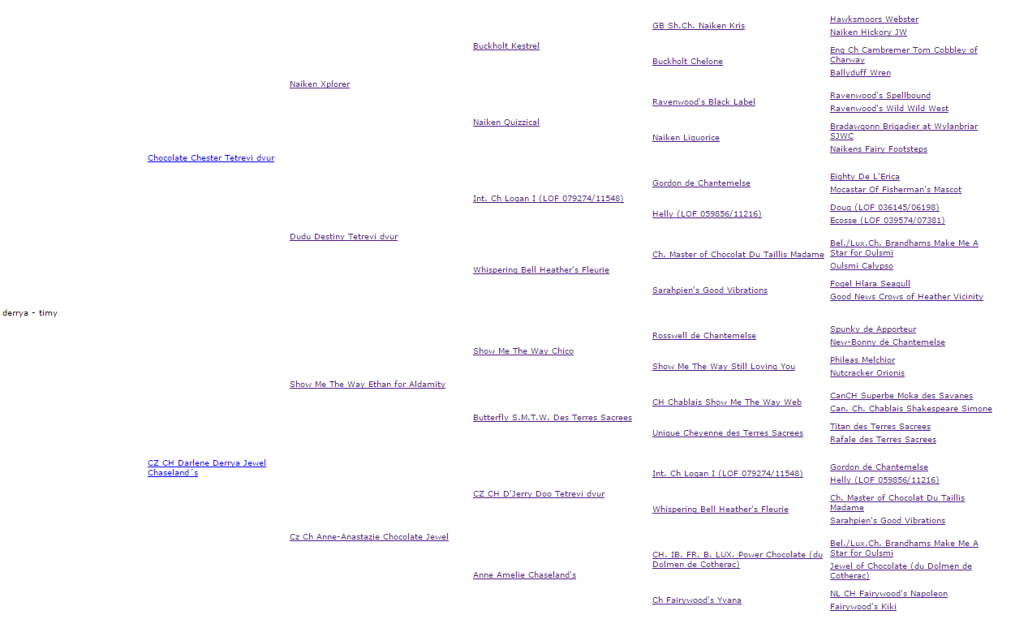
Rodokmen Litter C Alfa Sirius

